Response PSI
Singularity Details

Term | Details
Intercept | = - 0.78947*Julian Date[172] - 0.78947*Julian Date[173] - 0.78947*Julian Date[174] - 0.78947*Julian Date[179] - 0.78947*Julian Date[192] - 0.78947*Julian Date[193] - 0.78947*Julian Date[194] - 0.78947*Julian Date[195] - 0.78947*Julian Date[200] - 0.78947*Julian Date[201] - 0.78947*Julian Date[208] - 0.78947*Julian Date[222] + 1.89474*Julian Date[227] + 1.89474*Julian Date[234] + 1.89474*Julian Date[242] + 1.89474*Julian Date[248] - 0.89474*Tx[2L] - 0.89474*Tx[4L]

Whole Model
Actual by Predicted Plot
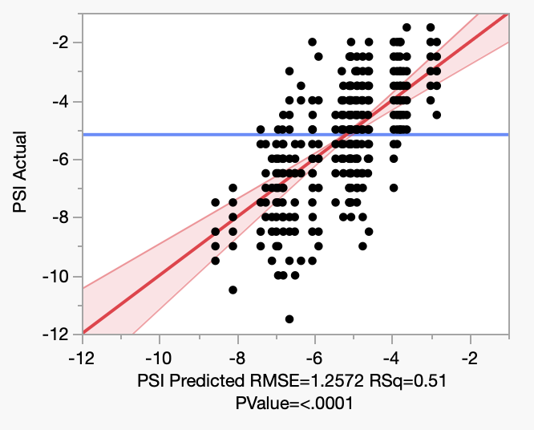

Effect Summary

Source | Logworth |  | PValue
Julian Date | 38.469 |  | 0.00000
Tx | 1.267 |  | 0.05402
Variety | 0.812 |  | 0.15404

Lack Of Fit

Source | DF | Sum of Squares | Mean Square | F Ratio
Lack Of Fit | 19 | 22.00663 | 1.15824 | 0.7258
Pure Error | 520 | 829.88109 | 1.59593 | Prob > F
Total Error | 539 | 851.88772 |  | 0.7935
 |  |  |  | Max RSq
 |  |  |  | 0.5180

Residual by Predicted Plot
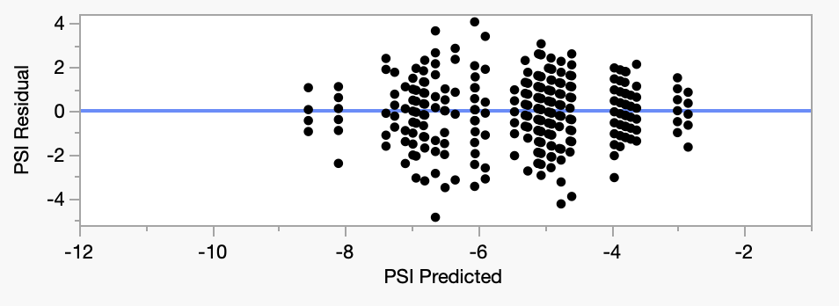

Summary of Fit

RSquare | 0.505209
RSquare Adj | 0.488686
Root Mean Square Error | 1.257178
Mean of Response | -5.17473
Observations (or Sum Wgts) | 558

Analysis of Variance

Source | DF | Sum of Squares | Mean Square | F Ratio
Model | 18 | 869.8260 | 48.3237 | 30.5750
Error | 539 | 851.8877 | 1.5805 | Prob > F
C. Total | 557 | 1721.7137 |  | <.0001*

Parameter Estimates

Term |  | Estimate | Std Error | t Ratio | Prob>|t|
Intercept | Biased | -5.620653 | 0.151577 | -37.08 | <.0001*
Julian Date[172] | Biased | 0.143325 | 0.216624 | 0.66 | 0.5085
Julian Date[173] | Biased | 1.380825 | 0.216624 | 6.37 | <.0001*
Julian Date[174] | Biased | 1.468325 | 0.216624 | 6.78 | <.0001*
Julian Date[179] | Biased | 1.293325 | 0.216624 | 5.97 | <.0001*
Julian Date[192] | Biased | 0.468325 | 0.216624 | 2.16 | 0.0311*
Julian Date[193] | Biased | 0.493325 | 0.216624 | 2.28 | 0.0232*
Julian Date[194] | Biased | -0.206675 | 0.285989 | -0.72 | 0.4702
Julian Date[195] | Biased | 2.243325 | 0.285989 | 7.84 | <.0001*
Julian Date[200] | Biased | 0.193325 | 0.216624 | 0.89 | 0.3726
Julian Date[201] | Biased | -0.006675 | 0.216624 | -0.03 | 0.9754
Julian Date[208] | Biased | -1.734453 | 0.225388 | -7.70 | <.0001*
Julian Date[222] | Biased | 0.1822139 | 0.225388 | 0.81 | 0.4192
Julian Date[227] | Biased | -0.35357 | 0.299567 | -1.18 | 0.2384
Julian Date[234] | Biased | -1.10357 | 0.299567 | -3.68 | 0.0003*
Julian Date[242] | Biased | -0.505642 | 0.368112 | -1.37 | 0.1701
Julian Date[248] | Biased | -1.394531 | 0.368112 | -3.79 | 0.0002*
Variety[CH] |  | -0.079979 | 0.05603 | -1.43 | 0.1540
Tx[2L] | Biased | -0.452328 | 0.234255 | -1.93 | 0.0540
Tx[4L] | Zeroed | 0 | 0 | . | .

Effect Tests

Source | Nparm | DF | Sum of Squares | F Ratio | Prob > F
Julian Date | 16 | 15 | 431.66044 | 18.2078 | <.0001* | LostDFs
Variety | 1 | 1 | 3.22034 | 2.0375 | 0.1540
Tx | 2 | 1 | 5.89283 | 3.7285 | 0.0540 | LostDFs

Julian Date
Leverage Plot
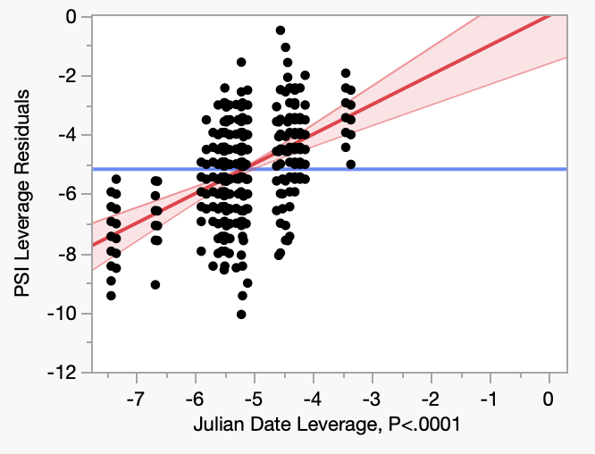

Variety
Leverage Plot
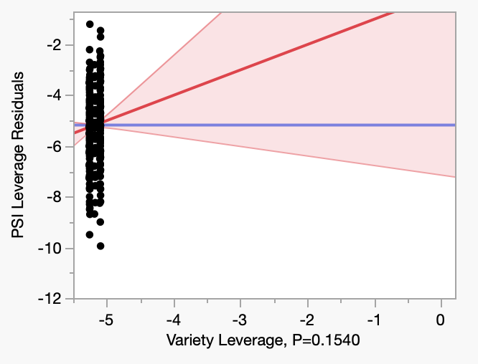

Least Squares Means Table

Level | Least Sq Mean |  | Std Error | Mean
CH | 0 | NonEstimable | . | -5.0337
CS | 0 | NonEstimable | . | -5.2908
Tx
Leverage Plot
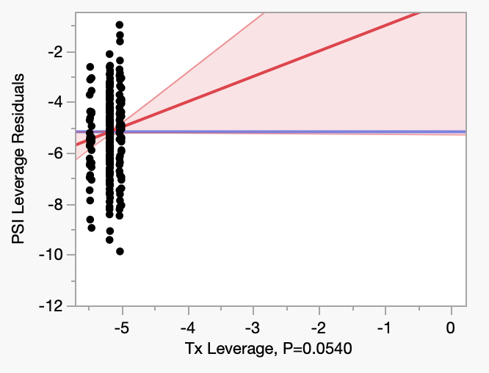

Least Squares Means Table

Level | Least Sq Mean |  | Std Error | Mean
2L | 0 | NonEstimable | . | -7.1111
4L | 0 | NonEstimable | . | -6.6296
NaN | 0 | NonEstimable | . | -4.7002

